
School Readiness
Preparing your child for starting school

Getting ready for school is an exciting time for children, parents and carers, visiting school, shopping for uniform and knowing who your new teachers are going to be.

As the time for starting school approaches some children will be ready and transition to school in their stride whilst others will need a little more help and encouragement from the adults in their lives.

In Blackburn with Darwen we have worked with Family Hubs, Health, Childminders, Nurseries and Schools to agree what we mean by ‘school readiness’. These providers told us, in order to make sure that children are able enjoy school and get off to a good start they need to:
- have well developed personal skills.
  - things like being able to put their coat on and feed themselves.
- have a level of emotional and social maturity.
  - are happy to leave you and are used to playing with groups of other children.
- have the ability to communicate, pay attention and learn.
  - be able to talk to their teachers and sit for a story.
- be healthy and well.
  - had all their injections and any health problems are being managed.
We have put some ideas, hints and tips together in this School Readiness document about things that you can do to help you to prepare your child for starting school. Keep it handy so you can use different ideas each day.

There is also lots of information available to support you in understanding your child’s development and how you can help them to thrive including ‘What to Expect in the Early Years Foundation Stage’
What-to-expect-in-the-EYFS-complete-FINAL-16.09-compressed.pdf (foundationyears.org.uk)

Your nursery or childminder will work in partnership with you to help you get your child ready for school as well as other services that offer advice, guidance and support such as your Health Visitor or your local Family Hub. Family Hub Website address: https://familyhubsbwd.org/

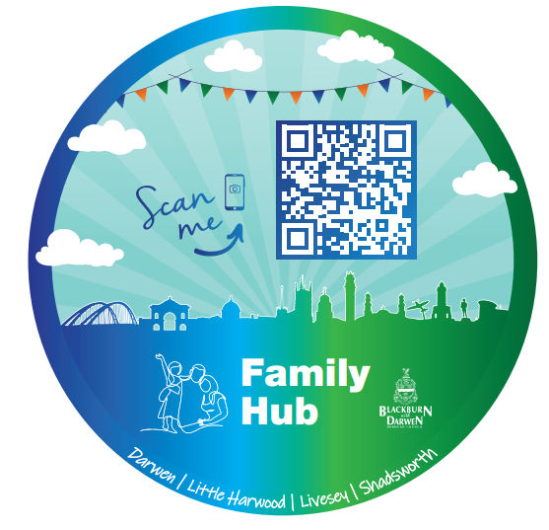
Good Parent Websites and apps
Tiny Happy People:
BBC Tiny Happy People

Words for Life / Literacy Trust:
Words for Life | National Literacy Trust | Words for Life

Love My Books
Welcome to lovemybooks! | lovemybooks

My First Five Years:
Home (mffy.com)

Preparing your child for starting School
 | Attend all health checks and immunisations.  Children will develop and learn if they are fit and healthy so make sure you keep up to date with all health checks including eye and hearing tests.  And don’t forget those immunisations especially the boosters!  Speak to a health professional or your child’s key person if you have concerns and are worried about your child’s development or health and wellbeing.
 | Good morning and night time routines.  A good routine for your child helps them to feel safe and secure.  Predictable patterns and knowing what to expect and what’s next will help your child to develop their confidence and emotional well-being which will reduce anxiety.
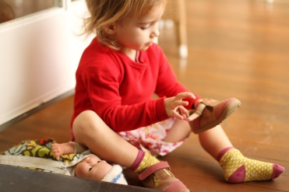 | Allow your child to be independent and do things for themselves.  Encourage your child to follow instructions to:  - put their own coat and shoes on and off  - go to the toilet  - wash their hands  - feed themselves.
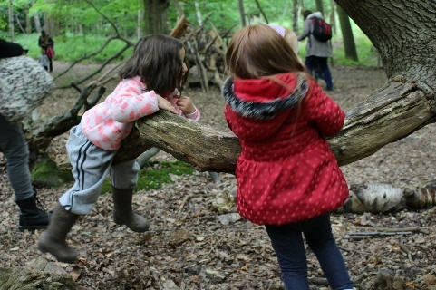 | Provide play opportunities and experiences both indoors and outside.  Plan activities with your child to experience the world with opportunities to play in different environments, and with different resources as this will develop and extend your child’s curiosity.
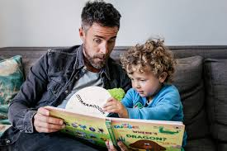 | Talk, read and sing with your child.  Spending time with your child chatting, reading and singing. Open the door to adventures, learning new things and a whole host of key language skills such as speech development and vocabulary building. These activities create special moments for you to bond with your child and enjoy each other’s company.  Allow at least 10-15 minutes a day to read stories together, look at books and sing songs to develop your child’s speaking and listening skills ready for school.

Many parents think that their child needs to be able to read, write their own name, recognise numbers and letters or do sums to be ready for school. This is a myth. Some children may be able to do these things but it is more important is that they feel confident to have a go and try new things.

I will be ready for school when… | How can you support me to do this?
I understand questions or instructions that have two parts, such as “Get your coat and wait at the door.” | - Play hide and seek games where I have to listen to your instructions.
I am able to talk about rhymes and books that I am familiar with. | - When we are sharing a story ask me how it might end.  - Ask me about the different pictures I can see on each page.
I use longer sentences of 4 -6 words. | - Encourage me to use longer sentences by allowing me time to talk and asking me lots of questions.
I use talk to organise my play and myself: “Let’s go on a bus, you sit there, I will be the driver.” | - Play with me and show me how to pretend to be a character and the types of things I could say whilst I am acting out my character’s role.
I can listen attentively and respond to what I hear. | - Read me a bedtime story before bed.  - Sing songs with me and rhymes that I can make actions to like heads, shoulders, knees and toes and wind the bobbin up etc.…  - Make up stories whilst we are walking so I can listen to them and tell you one too.
I play with at least one or more children, extending and elaborating my ideas. | - Take me to Toddler and Family Hub / play groups.  - Let me play with other children in the park and on outings.  - Let me talk to other adults when you are there.
I follow rules and can understand why they are important. | - Make sure I know what I’m allowed to do and not allowed to do.  - Give me boundaries and make sure I keep to them.  - Let’s make some house rules together.
I can talk about my feelings using words like: happy, sad, angry and worried. | - Read books like Owl Babies and Peace at Last so we can talk about how the different characters are feeling.  - Ask me questions about how I feel.  - Tell me how you are feeling.
I can share and take turns in a group. | - Play games with me where I have to wait until it’s my turn to go.  - Make sure I take turns at the park and on outings.  - Talk to me about why I need to share my toys.
I am independent when meeting my own care needs such as: brushing teeth, going to the toilet, feeding myself and washing my hands. | - Encourage me to go to the toilet independently and wash my own hands and brush my teeth. I know it may take a little extra time however you are teaching me to do it all by myself.
I can talk about ways to keep myself healthy such as brushing my teeth and eating healthy foods. | - Teach me to use a knife, fork, and spoon and make sure I don’t just eat with my hands.  - Provide a variety of meals so I can experience a range of foods.  - Let me help you prepare meals so I can talk about food and you can teach me new things.
I can demonstrate a range of physical skills such as balancing, riding, climbing and ball skills. | - Take me outside to play as much as possible and teach me games like ‘Simon say’s etc…
I can use fine motor skills with good control to make marks and use tools in my play. | - Let me help you peg out the washing.  - Let’s play with playdough so I can use my finger muscles.  - Let’s draw pictures on the path and paving stones with chunky chalks.
I can put on and take off my coat, shoes and apron. | - Show me how to take off my clothes and put them in a pile on a chair ready for PE lessons.  - Buy me some Velcro fastening shoes that I can put on and take them off by myself.
I can do up my coat using a zip or poppers etc… | - Show me my new school uniform and let me practice buttons and zips.
I can suggest the missing word in a Nursery Rhyme eg.. Hickory, Dickory, Dock the mouse ran up the…… | - Sing and read lots of nursery rhymes to me and talk about the word at the end sounding the same/rhyming – eg hickory, dickory, dock, the mouse ran down the clock …
I can count or clap syllables in a word. | - Talk about how many syllables there are in our names and clap them out eg: Natalie has three syllables Na/ta/lie;  - Thinks of longer words like caterpillar which has four syllables ca/ter/pil/lar
I can recognise words with the same initial sound, such as money and mother. | - Play I spy at home and when we’re out and about.  - Think of items that begin with the same sound and talk about the initial sound eg pencil, plum, paper, pan, pen…
I can engage in extended conversations about stories, learning new vocabulary. | - Always ask me questions and involve me in conversations where I have to give you an extended answer rather than just a yes or a no.  - When we are out walking, talk to me about the new experiences that I may be seeing.
I can use print and letter knowledge in my early writing e.g. writing a pretend shopping list that starts at the top of the page. | - Model how to write a letter, card, postcard and shopping lists. I can then copy you whilst I am playing. Don’t worry if it just looks like marks and scribble – this is the start of my early writing.
I know that the last number reached when counting a small set of objects tells you how many there are in total (cardinal principle). | - Play games where I have to count my toys, ducks in the bath, stairs at home, cars in the street etc…
I can solve real world mathematical problems with numbers up to 5. | - Use puzzles, games and Jigsaws to explore problem solving.  - Talk to me about how much things cost and money when we are out shopping.
I can make comparisons to objects relating to size, length, weight and capacity. | - Bake with me and talk to me about weighing the ingredients and how much we may need.  - Talk to me about different sizes of things I can see.
I understand the need to respect and care for the natural environment and all living things. | - Take me to the pet shop to show me different animals.  - Let me care for a pet.
I can talk about my family, community and wider experiences. | - Let me watch programmes about the natural environment and the world.  - Take me to local library to look at pictures of what other countries look like and talk to me about the differences I may be able to see.
I can explore different materials freely, in order to develop my ideas about how to use them and the different creations I can make. | - Do some fun activities with me like – painting, junk modelling, wrapping presents and collage.  - You can teach me to use different tools such as scissors, glue sticks and staplers correctly.
I know and can sing a few nursery rhymes and/or songs. | - Allow me to explore different Nursery Rhyme books.  - Teach me rhymes that you remember and know.  - Let me listen and sing along to rhymes and songs at home and in the car where possible.

